**TUGAS 07**

**PRAK08 Bistro App**



Praktikum Pemrograman Berbasis Web - A

Nama :

Adelia Nurlina Putri 4521210059

**PROGRAM STUDI S1 TEKNIK INFORMATIKA**

**FAKULTAS TEKNIK**

**UNIVERSITAS PANCASILA**

**JAKARTA**

**2024**

1. **Project prak08**
   1. **First Initialization**
2. Akses web <https://docs.flutter.dev/ui/layout/tutorial>
3. Buka Android Studio

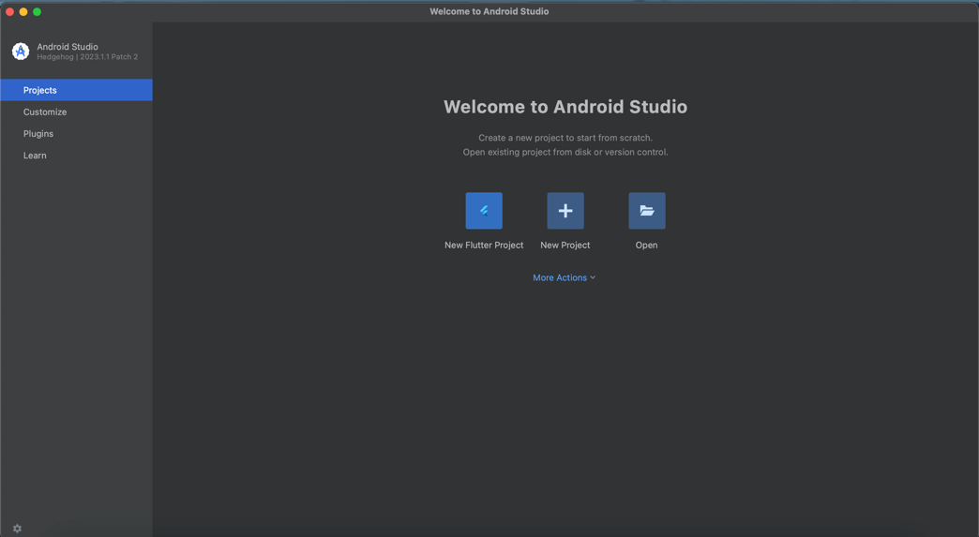

1. Pilih New Flutter Project -> Flutter -> Next

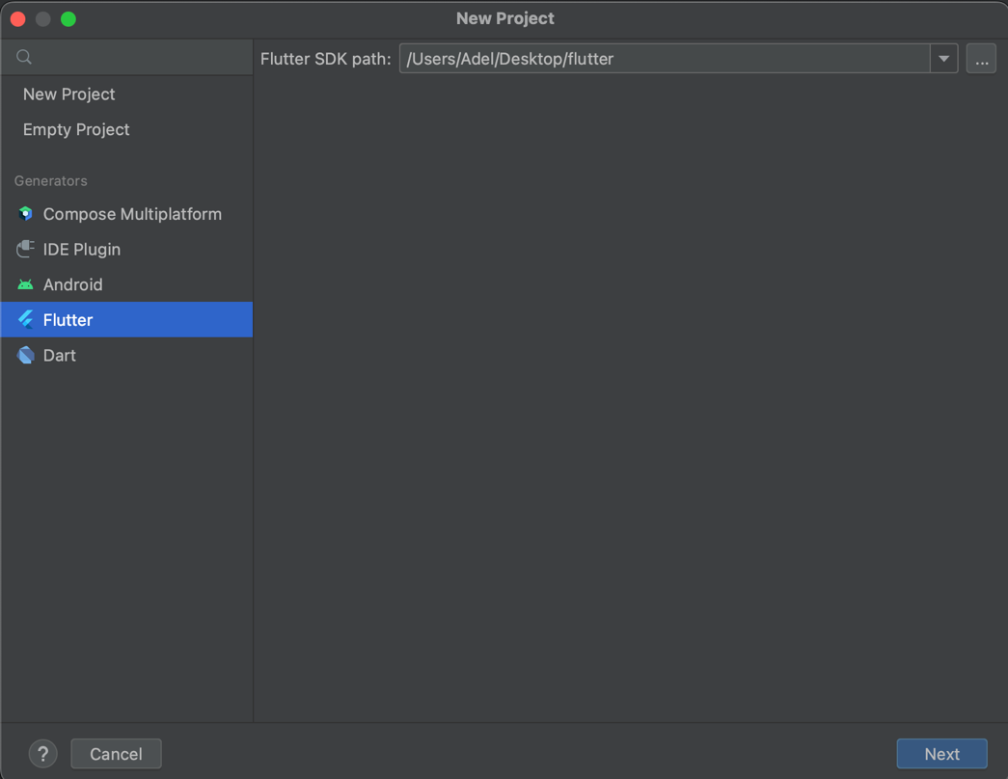

1. Isi form untuk nama project, tempat project, type, bahasa pemrograman, platforms dan lainnya -> Create

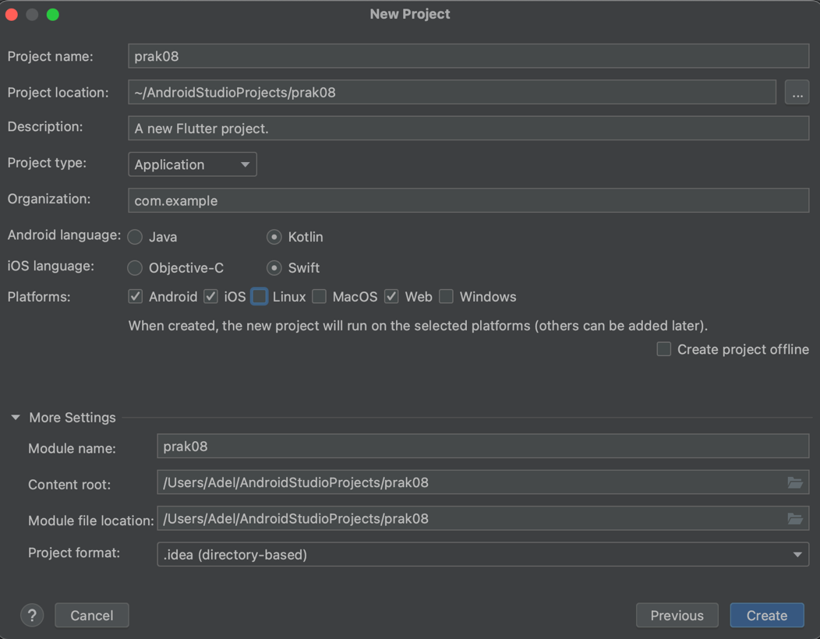

* 1. **Membuat Ap**

1. File main.dart

|  |
| --- |
| import 'package:flutter/material.dart';  import 'package:flutter/services.dart';  import 'package:http/http.dart';  import 'package:url_launcher/url_launcher.dart';  void main() {  runApp(const MyApp());  }  class MyApp extends StatelessWidget {  const MyApp({Key? key}) : super(key: key);  // This widget is the root of your application.  @override  Widget build(BuildContext context) {  return MaterialApp(  title: 'Praktikum Flutter Adelia Nurlina Putri',  theme: ThemeData(  primarySwatch: Colors.*blue*,  ),  home: const MyHomePage(),  );  }  }  class MyHomePage extends StatelessWidget {  const MyHomePage({Key? key}) : super(key: key);  @override  Widget build(BuildContext context) {  // This method is rerun every time setState is called, for instance as done  // by the _incrementCounter method above.  //  // The Flutter framework has been optimized to make rerunning build methods  // fast, so that you can just rebuild anything that needs updating rather  // than having to individually change instances of widgets.  return Scaffold(  appBar: AppBar(  // Here we take the value from the MyHomePage object that was created by  // the App.build method, and use it to set our appbar title.  title: const Text('Home'),  ),  body: Center(  // Center is a layout widget. It takes a single child and positions it  // in the middle of the parent.  child: Column(  mainAxisAlignment: MainAxisAlignment.center,  children: <Widget>[  const Text(  'Selamat datang do Praktikum Flutter',  ),  SizedBox(height: 20),  ElevatedButton(onPressed: () {  Navigator.*push*(  context,  MaterialPageRoute(builder: (context) => const MenuPage()),  );  },  child: const Text('Menu'),  ),  ElevatedButton(  onPressed: () {  Navigator.*push*(  context,  MaterialPageRoute(builder: (context) => const AboutPage()),  );  },  child: const Text('About'),  ),  ],  ),  ),  );  }  }  class MenuPage extends StatelessWidget {  const MenuPage ({Key? key}) : super(key: key);  @override  Widget build(BuildContext context) {  return Scaffold(  appBar: AppBar(  title: const Text('Menu'),  ),  body: const Center(  child: Text('Ini adalah halaman Menu.'),  ),  );  }  }  class AboutPage extends StatefulWidget {  @override  _AboutPageState createState() => _AboutPageState();  }  class _AboutPageState extends State<AboutPage> {  String restaurantExteriorUrl = 'https://images.unsplash.com/photo-1517248135467-4c7edcad34c4?ixlib=rb-4.0.3&ixid=MnwxMjA3fDB8MHxwaG90by1wYWdlfHx8{GVUfDB8fHx8&auto-format& fit=crop&w=1470&9=80';  String restaurantName = 'Adel Bistro Restaurant';  String restaurantLocation = 'Jl. Contoh No.1, Jakarta, Indonesia';  String mapsUrl = 'https://maps. google.com/?q=-6.200000,106.816666';  const AboutPage({Key? key}) : super(key: key);  @override  Widget build(BuildContext context){  return Scaffold(  appBar: AppBar(  title: const Text('About'),  ),  body: const Center(  child: Text('Ini adalah halaman About.'),  ),  );  }  } |

Kode di atas akan membuat aplikasi Flutter dengan tiga halaman: Home, Menu, dan About. Halaman Home memiliki dua tombol yang akan mengarahkan pengguna ke halaman Menu dan halaman About.

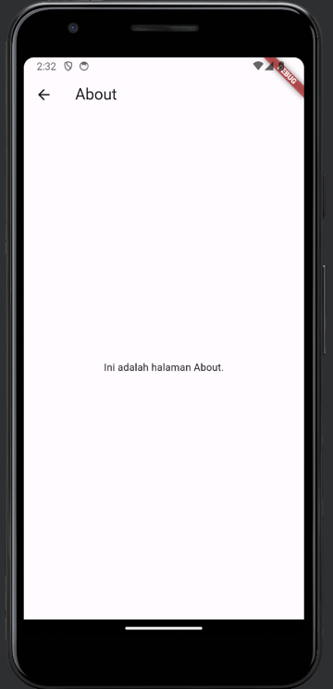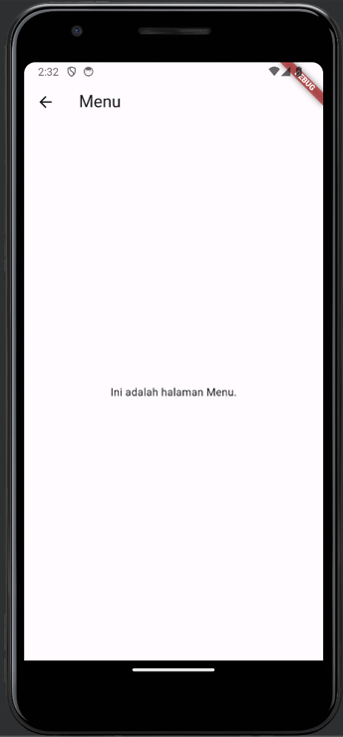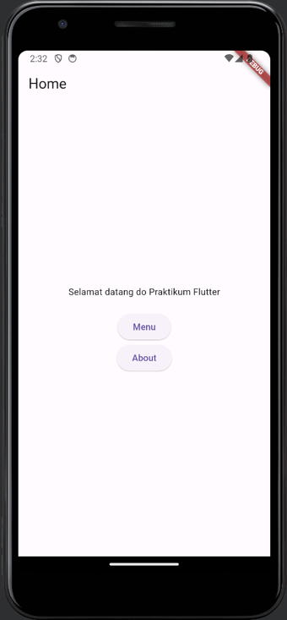

1. Add dependencies pada pubspec.yaml -> pub get

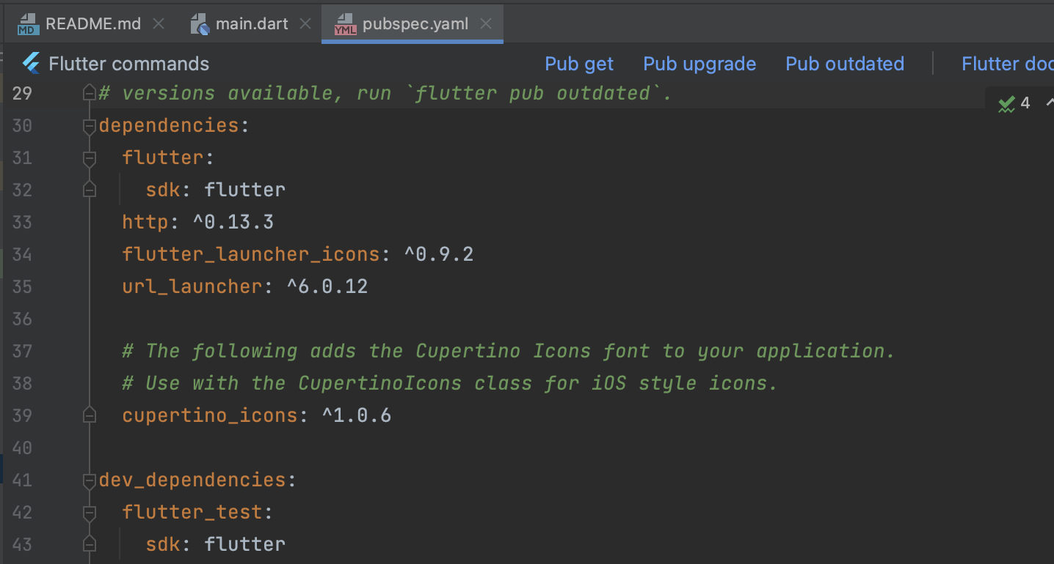

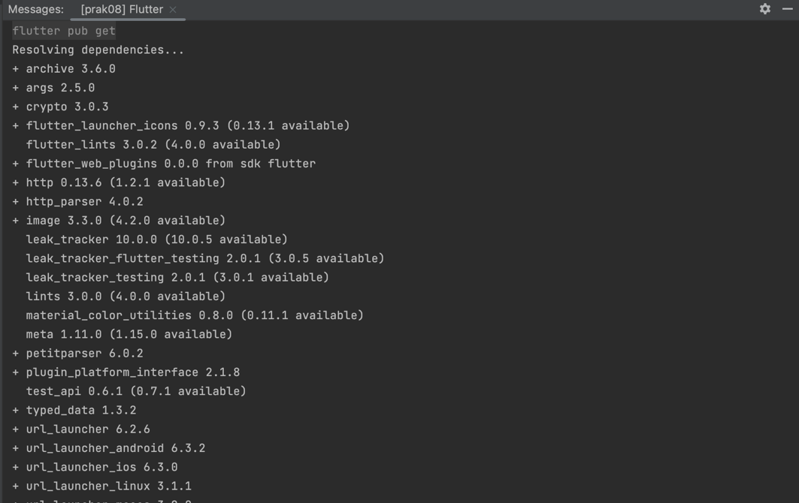

1. Edit class AboutPage menjadi stateful dan menambahkan beberapa atribut

|  |
| --- |
| class AboutPage extends StatefulWidget {  const AboutPage({Key? key}) : super(key: key);  @override  _AboutPageState createState() => _AboutPageState();  }  class _AboutPageState extends State<AboutPage> {  String restaurantExteriorUrl = 'https://images.unsplash.com/photo-1517248135467-4c7edcad34c4?ixlib=rb-4.0.3&ixid=MnwxMjA3fDB8MHxwaG90by1wYWdlfHx8{GVUfDB8fHx8&auto-format& fit=crop&w=1470&9=80';  String restaurantInteriorUrl = 'https://images.unsplash.com/photo-1587899897387-091ebd01a6b2?ixlib=rb-4.0.3&ixid=Mnw×MiA3fDB8MHxwaG90by1wYWd1fHx8£GVufDB8fHx8&auto=format&fit=crop&w=1513&9=80';  String restaurantName = 'Adel Bistro Restaurant';  String restaurantLocation = 'Jl. Contoh No.1, Jakarta, Indonesia';  String mapsUrl = 'https://maps. google.com/?q=-6.200000,106.816666';  @override  Widget build(BuildContext context) {  return Scaffold(  appBar: AppBar(  title: const Text('About'),  ),  body: SingleChildScrollView(  child: Padding(  padding: const EdgeInsets.all(16.0),  child: Column(  crossAxisAlignment: CrossAxisAlignment.start,  children: [  Text(  restaurantName,  style: TextStyle(fontSize: 24, fontWeight: FontWeight.*bold*),  ),  SizedBox(height: 16),  Text('Foto Luar Restoran:'),  SizedBox(height: 8),  Image.network(restaurantExteriorUrl),  SizedBox(height: 16),  Text('Foto Interior Restoran:'),  SizedBox(height: 8),  Image.network(restaurantInteriorUrl),  SizedBox(height: 16),  Text(  'Lokasi:',  style: TextStyle (fontSize: 18, fontWeight: FontWeight.*bold*),  ),  SizedBox(height: 8),  Text(restaurantLocation),  SizedBox(height: 8),  ElevatedButton.icon(  onPressed: () async {  await launch(mapsUrl);  },  icon: Icon(Icons.*map*),  label: Text('Buka di Google Maps'),  ),  ],  ),  ),  ),  );  }  } |

1. Membuat file baru untuk menambahkan menu berupa grid

|  |
| --- |
| Klik kanan dir lib -> New -> file -> food_menu.dart  class FoodMenu {  final String imageUrl;  final String name;  final double price;  FoodMenu({required this.imageUrl, required this.name, required this.price});  } |

1. Import file food_menu.dart ke main.dart

|  |
| --- |
| import 'food_menu.dart'; |

1. Edit class MenuPage

|  |
| --- |
| class MenuPage extends StatefulWidget {  const MenuPage ({Key? key}) : super(key: key);  @override  _MenuPageState createState() => _MenuPageState();  }  class _MenuPageState extends State<MenuPage> {  List<FoodMenu> foodMenus = [  FoodMenu (  imageUrl: 'https://images.unsplash.com/photo-1414235077428-338989a2e8c0?ixlib=rb-4.0.3&ixid=MnwxMjA3fDB8MHxwaG90bylwYWdlfHx8fGVufDB8fHx8&auto=format&fit=crор&w=1470&q=80',  name: 'Pasta',  price: 45000),  FoodMenu (  imageUrl: 'https://images.unsplash.com/photo-1676300185292-e23bb3db50fa?ixlib=rb-4.0.3&ixid=MnwxMjA3fDB8MHxwaG90bylwYWdlfHx8fGVufDB8fHx8&auto=format&fit=crop&w=1470&q=80',  name: 'Beef Bourguignon',  price: 55000),  FoodMenu (  imageUrl: 'https://images.unsplash.com/photo-1621841957884-1210fe19d66d?ixlib=rb-4.0.3&ixid=MnwxMjA3fDB8MHxwaG90bylwYWdlfHx8fGVufDB8fHx8&auto=format&fit=crop&w=1470&9=80',  name: 'Seafood Paella',  price: 135000),  FoodMenu (  imageUrl: 'https://images.unsplash.com/photo-1550675897-2505803ba4c0?ixlib=rb-4.0.3&ixid=MwxMjA3fDB8MHxwaG90by1wyWdlfHx8fGVufDB8fHx8&auto=format&fit=crop&w=1470&q=80',  name: 'Pastel de Nata',  price: 105000),  FoodMenu (  imageUrl: 'https://images.unsplash.com/photo-1601702538934-efffab67ab65?ixlib=rb-4.0.3&ixid=MnwxMjA3fDB8MHxwaG90by1wYWdlfHx8fGVufDB8fHx8&auto-format&fit=crop&w=1470&q=80',  name: 'Pickle Herring',  price: 71000),  FoodMenu (  imageUrl: 'https://images.unsplash.com/photo-1623961988350-66b064cb2977?ixlib=rb-4.0.3&ixid=MnwxMjA3fDB8MHxwaG90by1wYWdlfHx8fGVufDB8fHx8&auto=format&fit=crop&w=1470&q=80',  name: 'Carpaccio ',  price: 99000),  FoodMenu (  imageUrl: 'https://images.unsplash.com/photo-1610360147031-26ald395726e?ixlib=rb-4.0.3&ixid=MnwxMjA3fDB8MHxwaG90bylwyWdlfHx8fGVufDB8fHx8&auto=format&fit=crop&w=1470&q=80',  name: 'Roast & Yorkshire Pudding',  price: 45000),  FoodMenu (  imageUrl: 'https://images.unsplash.com/photo-1555196301-Sacc011ldfde4?ixlib=rb-4.0.3&ixid=MnwxMjA3fDB8MHxwaG90bylwYWdlfHx8fGVufDB8fHx8&auto=format&fit=crор&w=1470&q=80',  name: 'Gyros with Tzatziki',  price: 75000),  FoodMenu (  imageUrl: 'https://images.unsplash.com/photo-1604382354936-07c5d9983bd3?ixlib=rb-4.0.3&ixid-MnwxMjA3fDB8MHxwaG90by1wYWdlfHx8fGVufDB8fHx8&auto-format&fit=crop&w=1470&q=80',  name: 'Pizza with cheezy mushroom',  price: 85000),  FoodMenu (  imageUrl: 'https://images.unsplash.com/photo-1624371414361-e670edf4898d?ixlib=rb-4.0.3&ixid=MnwxMjA3fDB8MHxwaG90by1wYWdlfHx8fGVufDB8fHx8&auto=format&fit=crop&w=1470&q=80',  name: 'Churros',  price: 45000),  ];  @override  Widget build(BuildContext context) {  return Scaffold(  appBar: AppBar(  title: const Text('Menu'),  ),  body: GridView.builder (  itemCount: foodMenus. length,  gridDelegate: SliverGridDelegateWithFixedCrossAxisCount (  crossAxisCount: 2,  childAspectRatio: 0.8,  ),  itemBuilder: (BuildContext context, int index) {  return GestureDetector(  onTap: () {  Navigator.*push*(  context,  MaterialPageRoute(  builder: (context) =>  FoodDetailPage(foodMenu: foodMenus[index]),  ),  );  },  child: Card(  child: Column(  children: [  Expanded(  child: Image.network(  foodMenus[index].imageUrl,  fit: BoxFit.cover,  ),  ),  Padding(  padding: const EdgeInsets.all(8.0),  child: Text(  foodMenus [index].name,  style: TextStyle(fontWeight: FontWeight.*bold*),  ),  ),  Text('Rp ${foodMenus[index].price.toStringAsFixed(0)}'),  ],  ),  ),  );  },  ),  );  }  } |

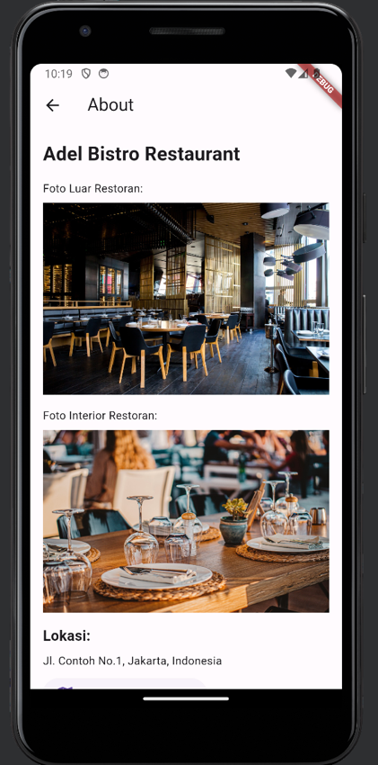

1. Buat class FoodDetailPage untuk halaman detail menu makanan

|  |
| --- |
| class FoodDetailPage extends StatelessWidget {  final FoodMenu foodMenu;  FoodDetailPage ( {required this. foodMenu});  @override  Widget build (BuildContext context) {  return Scaffold (  appBar: AppBar (  title: Text (foodMenu.name),  ),  body: SingleChildScrollView(  child: Padding(  padding: const EdgeInsets.all(16.0),  child: Column (  crossAxisAlignment: CrossAxisAlignment.start,  children: [  Image.network(foodMenu.imageUrl),  SizedBox (height: 16),  Text (  foodMenu.name,  style: TextStyle (fontSize: 24, fontWeight: FontWeight.*bold*),  ) ,  SizedBox (height: 8),  Text ('Harga: Rp ${foodMenu.price.toStringAsFixed(0)}') ,  ],  ),  ),  ),  );  }  } |

Dengan perubahan tersebut, halaman Menu akan menampilkan grid yang berisi 10 menu makanan dengan foto, nama, dan harga. Ketika salah satu menu ditekan, halaman detail menu makanan akan ditampilkan yang berisi foto lebih besar, nama makanan, dan harganya.

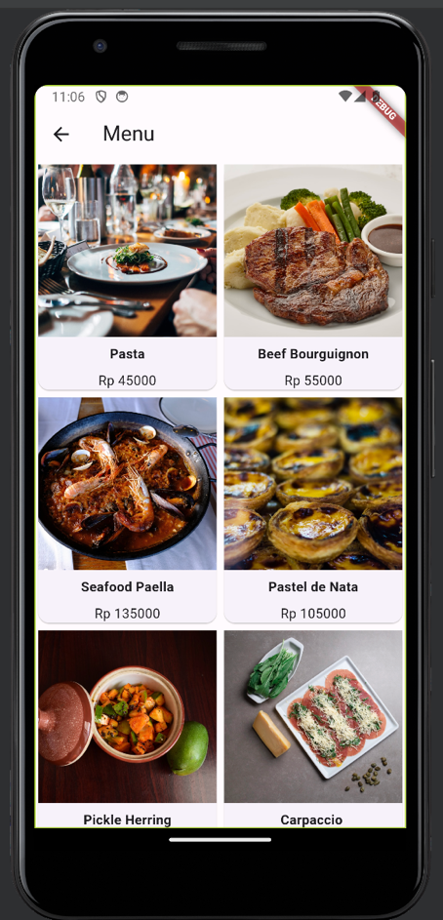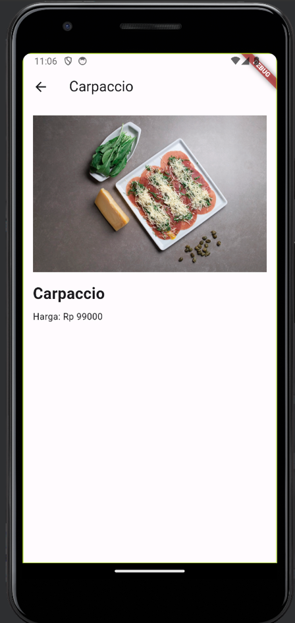

1. Buat file baru bernama cart_item.dart untuk menambah fitur keranjang

|  |
| --- |
| import 'food_menu.dart';  class CartItem {  FoodMenu foodMenu;  int quantity;  CartItem({required this.foodMenu, this.quantity = 1});  } |

1. Import file cart_item.dart ke main.dart

|  |
| --- |
| import 'cart_item.dart'; |

1. Edit class MenuPageState

|  |
| --- |
| class MenuPage extends StatefulWidget {  const MenuPage ({Key? key}) : super(key: key);  @override  _MenuPageState createState() => _MenuPageState();  }  class _MenuPageState extends State<MenuPage> {  List<CartItem> cartItems = [];  List<CartItem> _cartItems = [];  List<FoodMenu> foodMenus = [  FoodMenu (  imageUrl: 'https://images.unsplash.com/photo-1414235077428-338989a2e8c0?ixlib=rb-4.0.3&ixid=MnwxMjA3fDB8MHxwaG90bylwYWdlfHx8fGVufDB8fHx8&auto=format&fit=crор&w=1470&q=80',  name: 'Pasta',  price: 45000),  FoodMenu (  imageUrl: 'https://images.unsplash.com/photo-1676300185292-e23bb3db50fa?ixlib=rb-4.0.3&ixid=MnwxMjA3fDB8MHxwaG90bylwYWdlfHx8fGVufDB8fHx8&auto=format&fit=crop&w=1470&q=80',  name: 'Beef Bourguignon',  price: 55000),  FoodMenu (  imageUrl: 'https://images.unsplash.com/photo-1621841957884-1210fe19d66d?ixlib=rb-4.0.3&ixid=MnwxMjA3fDB8MHxwaG90bylwYWdlfHx8fGVufDB8fHx8&auto=format&fit=crop&w=1470&9=80',  name: 'Seafood Paella',  price: 135000),  FoodMenu (  imageUrl: 'https://images.unsplash.com/photo-1550675897-2505803ba4c0?ixlib=rb-4.0.3&ixid=MwxMjA3fDB8MHxwaG90by1wyWdlfHx8fGVufDB8fHx8&auto=format&fit=crop&w=1470&q=80',  name: 'Pastel de Nata',  price: 105000),  FoodMenu (  imageUrl: 'https://images.unsplash.com/photo-1601702538934-efffab67ab65?ixlib=rb-4.0.3&ixid=MnwxMjA3fDB8MHxwaG90bylwYWdlfHx8fGVufDB8fHx8&auto-format&fit=crop&w=1470&q=80',  name: 'Pickle Herring',  price: 71000),  FoodMenu (  imageUrl: 'https://images.unsplash.com/photo-1623961988350-66b064cb2977?ixlib=rb-4.0.3&ixid=MnwxMjA3fDB8MHxwaG90by1wYWdlfHx8fGVufDB8fHx8&auto=format&fit=crop&w=1470&q=80',  name: 'Carpaccio ',  price: 99000),  FoodMenu (  imageUrl: 'https://images.unsplash.com/photo-1610360147031-26a1d395726e?ixlib=rb-4.0.3&ixid=MnwxMjA3fDB8MHxwaG90by1wyWdlfHx8fGVufDB8fHx8&auto=format&fit=crop&w=1470&q=80',  name: 'Roast & Yorkshire Pudding',  price: 45000),  FoodMenu (  imageUrl: 'https://images.unsplash.com/photo-1555196301-9acc011dfde4?ixlib=rb-4.0.3&ixid=MnwxMjA3fDB8MHxwaG90bylwYWdlfHx8fGVufDB8fHx8&auto=format&fit=crор&w=1470&q=80',  name: 'Gyros with Tzatziki',  price: 75000),  FoodMenu (  imageUrl: 'https://images.unsplash.com/photo-1604382354936-07c5d9983bd3?ixlib=rb-4.0.3&ixid-MnwxMjA3fDB8MHxwaG90by1wYWdlfHx8fGVufDB8fHx8&auto-format&fit=crop&w=1470&q=80',  name: 'Pizza with cheezy mushroom',  price: 85000),  FoodMenu (  imageUrl: 'https://images.unsplash.com/photo-1624371414361-e670edf4898d?ixlib=rb-4.0.3&ixid=MnwxMjA3fDB8MHxwaG90by1wYWdlfHx8fGVufDB8fHx8&auto=format&fit=crop&w=1470&q=80',  name: 'Churros',  price: 45000),  ];  void _addToCart(FoodMenu foodMenu) {  setState(() {  _cartItems.add(CartItem(foodMenu: foodMenu));  print("_cartItems");  _cartItems.forEach((element) {  print(element.foodMenu.name);  });  });  }  @override  Widget build(BuildContext context) {  return Scaffold(  appBar: AppBar(  title: Text('Menu'),  actions: [  IconButton(  icon: Icon(Icons.shopping_cart),  onPressed: () {  Navigator.push(  context,  MaterialPageRoute(  builder: (context) => CartDialog(cartItems: cartItems),  ),  );  },  ),  ],  ),  body: GridView.builder (  itemCount: foodMenus. length,  gridDelegate: SliverGridDelegateWithFixedCrossAxisCount (  crossAxisCount: 2,  childAspectRatio: 0.8,  ),  itemBuilder: (BuildContext context, int index) {  return GestureDetector(  onTap: () {  Navigator.push(  context,  MaterialPageRoute(  builder: (context) =>  FoodDetailPage(foodMenu: foodMenus[index],  addToCart: _addToCart,  cartItems: _cartItems,  ),  ),  );  },  child: Card(  child: Column(  children: [  Expanded(  child: Image.network(  foodMenus[index].imageUrl,  fit: BoxFit.cover,  ),  ),  Padding(  padding: const EdgeInsets.all(8.0),  child: Text(  foodMenus [index].name,  style: TextStyle(fontWeight: FontWeight.bold),  ),  ),  Text('Rp ${foodMenus[index].price.toStringAsFixed(0)}'),  ],  ),  ),  );  },  ),  );  }  } |

1. Edit class FoodDetailPage

|  |
| --- |
| class FoodDetailPage extends StatelessWidget {  final FoodMenu foodMenu;  final List<CartItem> cartItems;  final void Function(FoodMenu) addToCart;  FoodDetailPage ( {  Key? key,  required this.foodMenu,  required this.addToCart,  required this.cartItems,  }) : super(key: key);  @override  Widget build (BuildContext context) {  return Scaffold (  appBar: AppBar (  title: Text (foodMenu.name),  actions: [  IconButton(  icon: Icon(Icons.shopping_cart),  onPressed: () {  Navigator.push(  context,  MaterialPageRoute(  builder: (context) => CartDialog(cartItems: cartItems),  ),  );  },  ),  ],  ),  body: SingleChildScrollView(  child: Padding(  padding: const EdgeInsets.all(16.0),  child: Column (  crossAxisAlignment: CrossAxisAlignment.start,  children: [  Image.network(foodMenu.imageUrl),  SizedBox (height: 16),  Text (  foodMenu.name,  style: TextStyle (fontSize: 24, fontWeight: FontWeight.bold),  ) ,  SizedBox (height: 8),  Text ('Harga: Rp ${foodMenu.price.toStringAsFixed(0)}') ,  ElevatedButton(onPressed: () {  addToCart(foodMenu);  ScaffoldMessenger.of(context).showSnackBar(  SnackBar(  content:  Text('${foodMenu.name} ditambahkan ke keranjang'),  ),  );  },  child: Text('Tambah ke Keranjang'),  ),  ],  ),  ),  ),  );  }  } |

1. Buat class CartDialog untuk menampilkan jumlah item dan harga pesanan

|  |
| --- |
| class CartDialog extends StatelessWidget {  final List<CartItem> cartItems;  CartDialog({required this.cartItems});  @override  Widget build(BuildContext context) {  int itemCount = cartItems.fold<int>(0, (sum, item) => sum + item.quantity);  double totalPrice = cartItems.fold<double>(0, (sum, item) => sum + item.foodMenu.price * item.quantity);  print("itemCount $itemCount");  print("totalPrice $totalPrice");  return Scaffold(  appBar: AppBar(  title: Text("Keranjang"),  ),  body: Column(  children: [  ListView.builder(  shrinkWrap: true,  itemCount: cartItems.length,  itemBuilder: (BuildContext context, int index) {  print("a. $cartItems");  return ListTile(  leading: Image.network(  cartItems[index].foodMenu.imageUrl,  width: 50,  height: 50,  fit: BoxFit.cover,  ),  title: Text(cartItems[index].foodMenu.name),  subtitle: Text (  'RP ${cartItems[index].foodMenu.price.toStringAsFixed(0)} x ${cartItems[index].quantity.toStringAsFixed(0)}'),  );  },  ),  Align(  alignment: Alignment.centerRight,  child: Padding(  padding: const EdgeInsets.all(8.0),  child: Text("Total Price Rp. $totalPrice"),  )  )  ],  ),  );  }  } |

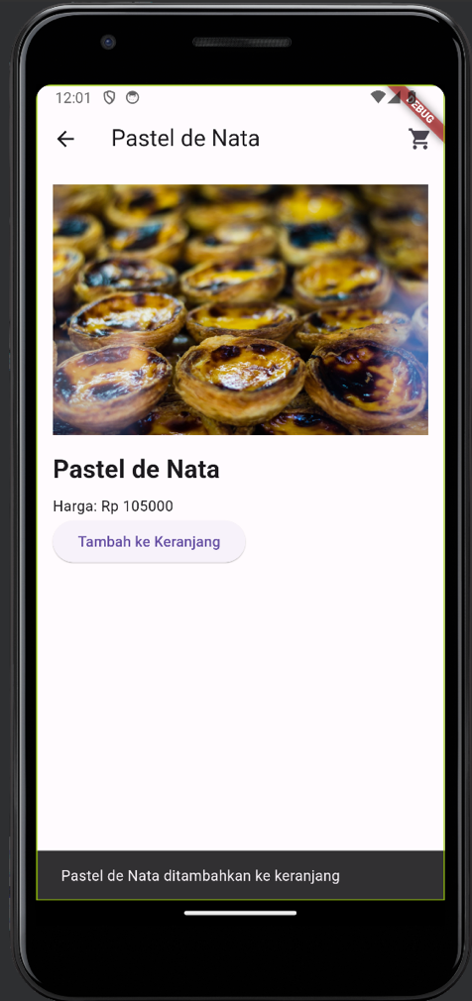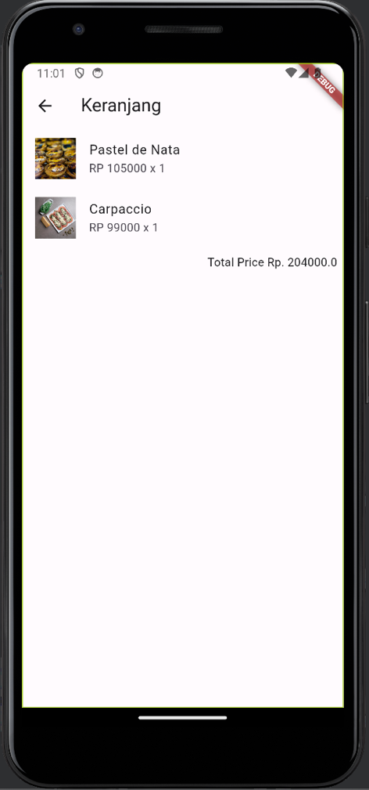

* 1. **Push Code to GitHub** <https://github.com/adelianurlinap/Prak_PBM.git>
     1. Clone Repository yang telah dibuat :

|  |
| --- |
| git clone https://github.com/adelianurlinap/Prak_PBM.git |

* + 1. Add dan commit

|  |
| --- |
| git add .  git commit -m "Tugas7" |

* + 1. Push code

|  |
| --- |
| git push |

1. **Kesimpulan**

Pada tugas 7 ini, telah dilakukan praktek untuk membuat stateful widget untuk membuat aplikasi cerita interaktif

1. **Referensi**

modul prak08